**An agent-based model of the 2020 tipping point in global covid policy response with integrated data assimilation**

Yannick Oswald, Nick Malleson, Keiran Suchak

**Parameter calibration details**

Distribution of initiative threshold meaning there are few early adopters

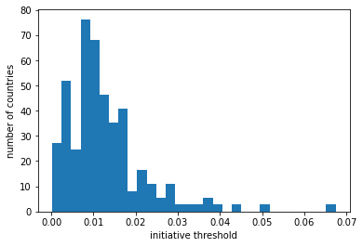

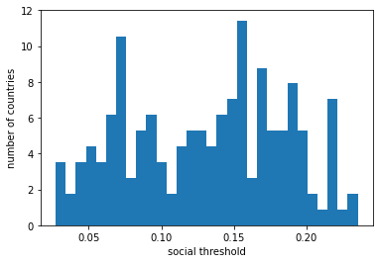

**Parameter sensitivity analysis**

…

**Direct data updates experiments**

In this experiment we test what happens if we re-initialize the model "in-between" from complete data again. We do this because this way we can test the behaviour of the model and also benchmark the particle filter. In effect this experiment is also a data assimilation application because we feed new observations directly into the model. But in contrast to the actual particle filter, all particle diversity is removed, that is all simulation runs are set to the same conditions again.

Direct data update at t = 5 and t = 10 leads to complete diversity loss.

At t= 5 only works

